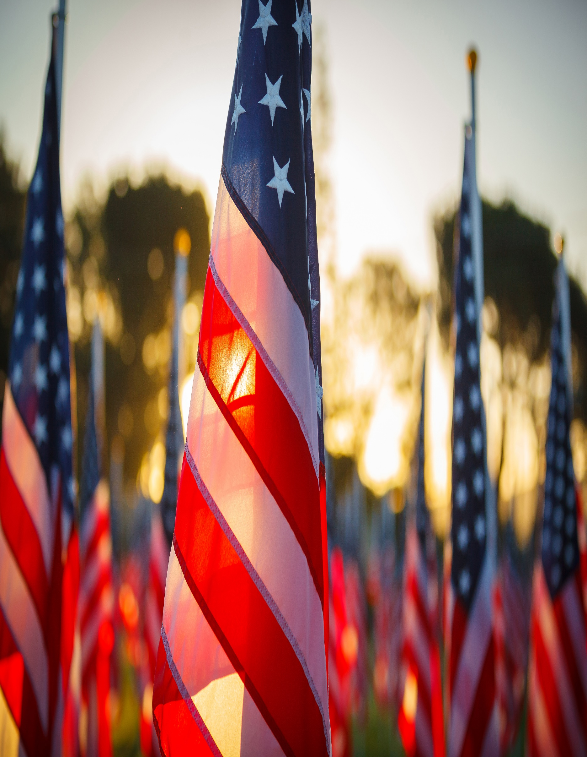
Operation Barnabas
Operation Barnabas is coming to Living Savior Lutheran Church!
- When?
  - Saturday, January 6th, 2024
  - Presentation by Chaplain Steve Hokana of the LCMS Ministry to the Armed Forces is from 9:00am-12:00, to be followed by lunch.
- Where?
  - Living Savior Lutheran Church, 5500 Ox Road, Fairfax Station, VA, 22039
  - Lunch will be provided!
- What to Expect
  - On Saturday, January 6th, Chaplain Hokana will be giving a presentation on the work Operation Barnabas does and how they can support your church in creating a military ministry of its own from 9:00am to 12:00pm with lunch to follow.
  - Everyone is encouraged to come to the presentation on Saturday, January 6th, to learn more about this great ministry, and to bring anyone with them who is interested as well!
  - Please RSVP (so we have enough food!!) by sending an email to Vicar Stephen Wareham at vicar@livingsaviorlutheran.org
  - If you would like to attend but are unable to in person, the presentation will be streamed on Living Savior’s website, https://www.livingsaviorlutheran.org
  - For more information on Operation Barnabas and the LCMS’ Ministry to the Armed Forces and the work that they and connected congregations do, please see their websites:
  - https://www.lcms.org/ministry-to-the-armed-forces
  - https://www.lcms.org/ministry-to-the-armed-forces/operation-barnabas


What is Operation Barnabas?
- Operation Barnabas is the LCMS’ network of care to our nation’s military members, families and veterans. We reach out to all branches of the military. Through this program — the only one of its kind in the U.S. — together with our congregations, we accomplish three key goals:
  - 1. Care for Military chaplains and their families and congregations.
  - 2. Train and assist local congregations in the care, support and outreach to all military connected people in their congregations and their communities.
  - 3. Serve as a resource to other organizations that provide care to military connected people.
Meet Our Presenter!
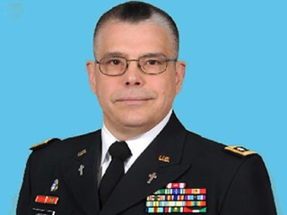
Rev. Dr. Steven Hokana, Chaplain (Lieutenant Colonel) USA (Ret.) BCC, D.A.A.E.T.S.
Assistant Director, LCMS Ministry to the Armed Forces
Chaplain Steven Hokana serves as the Assistant Director of Ministry to the Armed Forces for The Lutheran Church—Missouri Synod (LCMS). He brings more than 26 years of experience as an active-duty U.S. Army chaplain to the position. He is a board-certified chaplain and an active member of the Association of Professional Chaplains. In addition, he is a member of the Association for Clinical Pastoral Education (ACPE).
Hokana’s military service took him to Southwest Asia, Cuba, Bosnia, Germany, Denmark, Alaska, and on multiple stateside assignments. His career culminated in his service as chaplain of the 13th Sustainment Command (Expeditionary), where he supervised 44 chaplains and chaplain assistants who provided religious-support operations to thousands of soldiers, Department of Defense civilians, and contractors in Iraq, Afghanistan, and multiple other nations in Southwest Asia.
Hokana also is the recipient of the Army Medical Command, Order of Medical Military Merit and the Bronze St. Martin of Tours award for more than 20 years of service as a chaplain in the LCMS. Hokana and his wife of forty year years, Mary, have three children and five grandchildren.

